Clement Mabelebele
ST10507632
POE

Response

The feedback that I was given for part 2 was that I needed more complex CSS the CSS I used was basic and it needs more depth

So, from the feedback I got I added more complex CSS that was required that had depth that the lecturer needed by enhancing it with CSS that had animations and more complex hovers that blended in well with both the html and the JavaScript.

Before

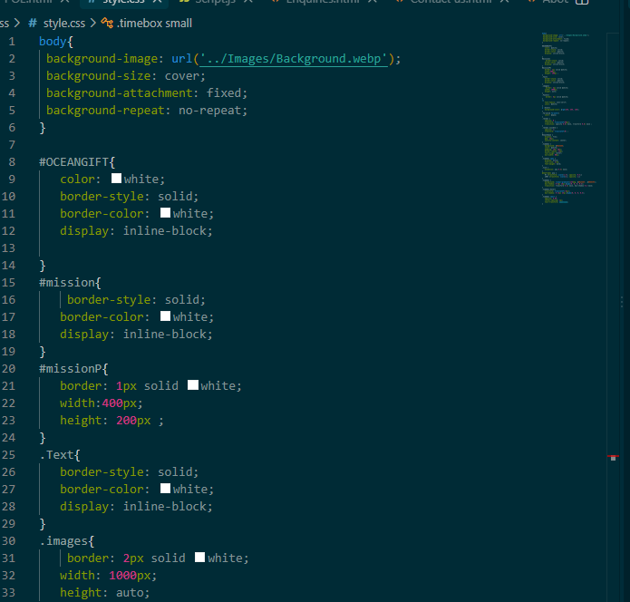
Figure 1: This is the simple CSS from part 2

After

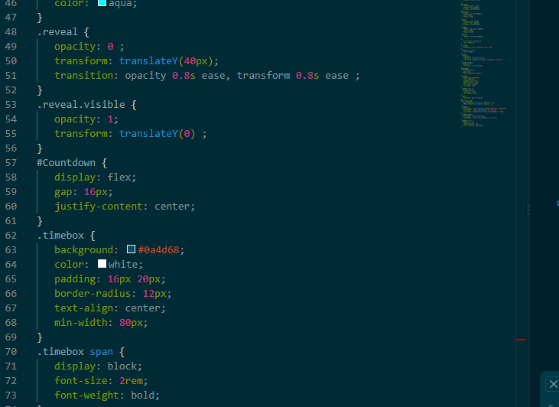
Figure1.2 This is the complex CSS that was added PT1

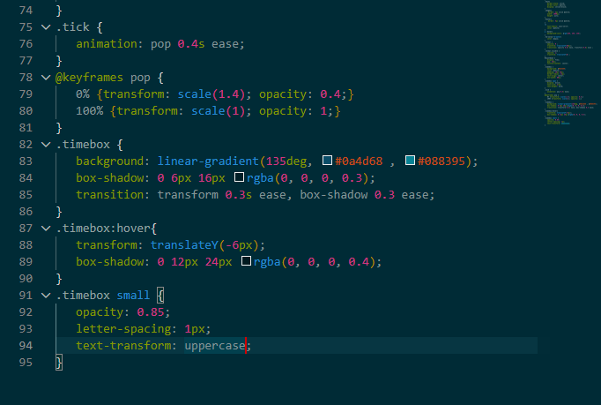

Figure 1.3 PT3 more complex CSS

